## <https://www.honeycombindia.net/graphic-design-artwork-production.php>

1. Alt Tag Mission : assets/media/services/graphical/Graphic_Design.jpg
2. Text Missing: Our Graphic Design Services Include -> Advertisement Design Tab

Our Graphic Design Services Include -> Illustrations and caricatures Tab

Our Graphic Design Services Include -> Copy development Services Tab

1. 404: artworking services-> Please add this link <http://artworknimage.com/>

## https://www.honeycombindia.net/canvas-printing.php

1. Text Missing: assets/media/9900-(550-x-310).png

assets/img/honeycomb_logos/logos-03.svg

1. In footer one bar is showing : You loaded this page on: Wed Jul 05 2017 12:29:15 GMT+0530 (India Standard Time)

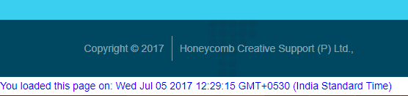

## <https://www.honeycombindia.net/news-paper-proofing.php>

1. 404: Standard Newsprint Tab

Semi matte art paper Tab

Pink Newsprint

1. Alt Tag missing: assets/media/cmyk-spoofing.png

## <https://www.honeycombindia.net/team.php>

1. 404: Wrong Link added -> <https://www.honeycombindia.net/contactus.html>  
   <https://www.honeycombindia.net/careers.html>  
   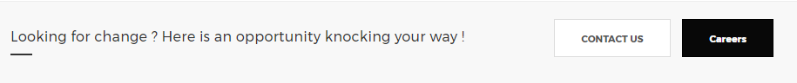

## <https://www.honeycombindia.net/news-and-updates.php>

1. Each and Every post title should be clickable
2. Recent News And Updates -> Link should be clickable

## <https://www.honeycombindia.net/sitemap.xml>

1. Few urls not added in sitemap : http://blog.honeycombindia.net/  
   <https://www.honeycombindia.net/faq.php>  
   <https://www.honeycombindia.net/privacy.php>

## <https://www.honeycombindia.net/contactus.php>

1. In Footer one bar is showing : You loaded this page on: Wed Jul 05 2017 12:47:07 GMT+0530 (India Standard Time)

## <https://www.honeycombindia.net/careers.php>

1. Form not submitted properly

## Header

1. Youtube social icon : add this url https://www.youtube.com/channel/UCkWEqpL6_qzjcbived7qQaw